IoT based Safety Gadget for child safety monitoring & Notification

Team ID : PNT2022TMID16918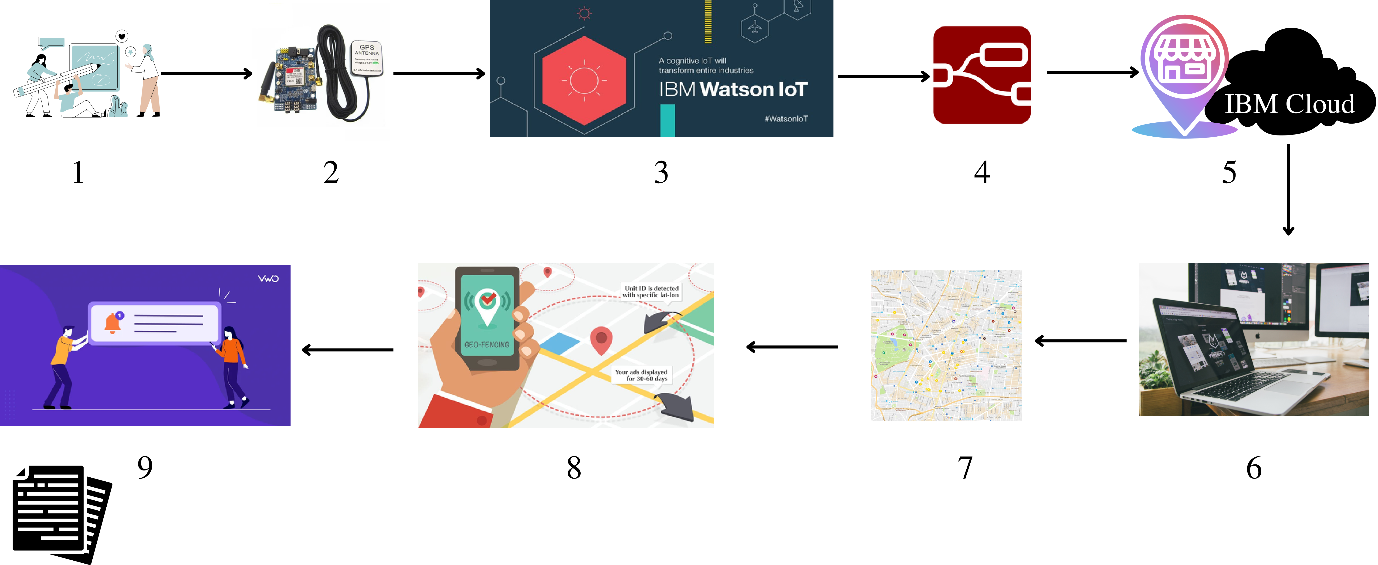

Turn over

IoT based Safety Gadget for child safety monitoring & Notification

3.Get Location from

|  |  |  |
| --- | --- | --- |
| 1.Planning | 2.Designing IoT Kit | Kit using Watson IoT Platform |
| 4.Connect it to NodeRed platform | 5.Store Location in IBM Cloud | 6.Create Web UI |
| 7.Display Current | 8.Create Geofence | 9.Send Notification |

Location